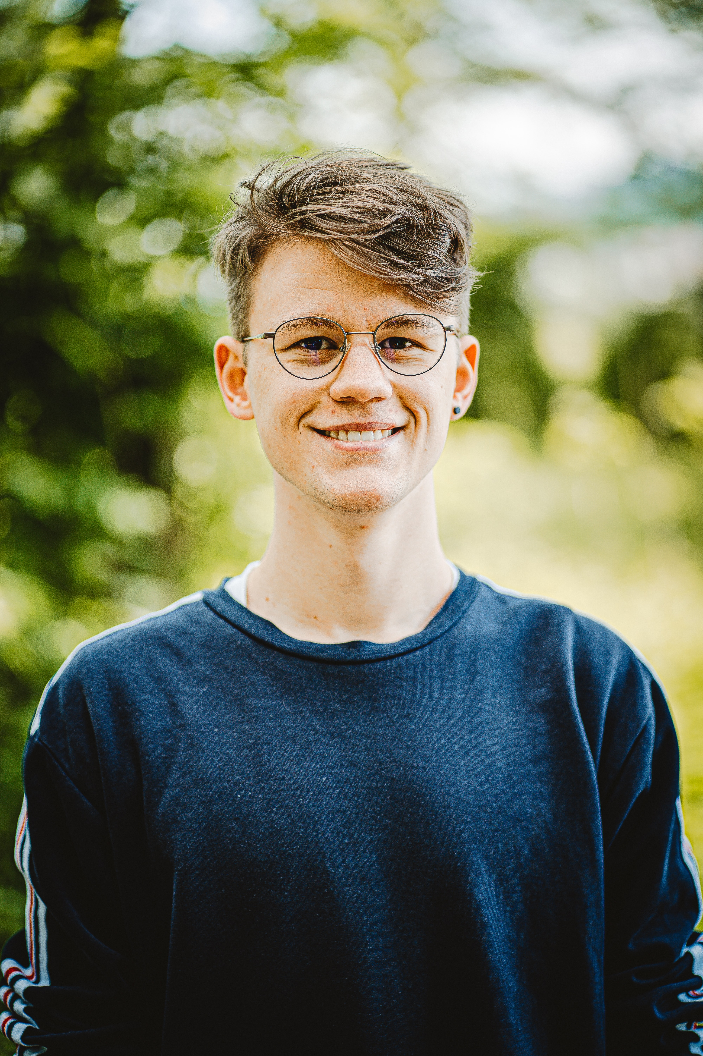

Persona #1 “Student”:

Photo credits: Photo by [Carlos Lindner](https://unsplash.com/@realbench?utm_source=unsplash&utm_medium=referral&utm_content=creditCopyText) on [Unsplash](https://unsplash.com/s/photos/male-student?utm_source=unsplash&utm_medium=referral&utm_content=creditCopyText) https://unsplash.com/photos/ZVo7vtXilCs

Demographic:

Age:20

Gender: Male

Status: Single

Educational Level: Student in college

Native Languages: English/Spanish

Description: Joe is a student studying computer science. He finds he is up long nights studying. He is very busy and can get stressed out sometimes.

Expertise:

Technical Expertise: 8/10

Domain Expertise: 7/10

Goals:

1. Use the platform to help go to sleep

2. Use the platform as background noise for studying and doing homework.

Motivations

1. Better sleep will help improve overall mental health

2. Improved sleep health will help him be more productive

3. Improved overall cognition

4. Reduced stress

Frustrations

1. Concentration

2. With a busy schedule he just wants a simple app to use that has a fast and easy learning curve.

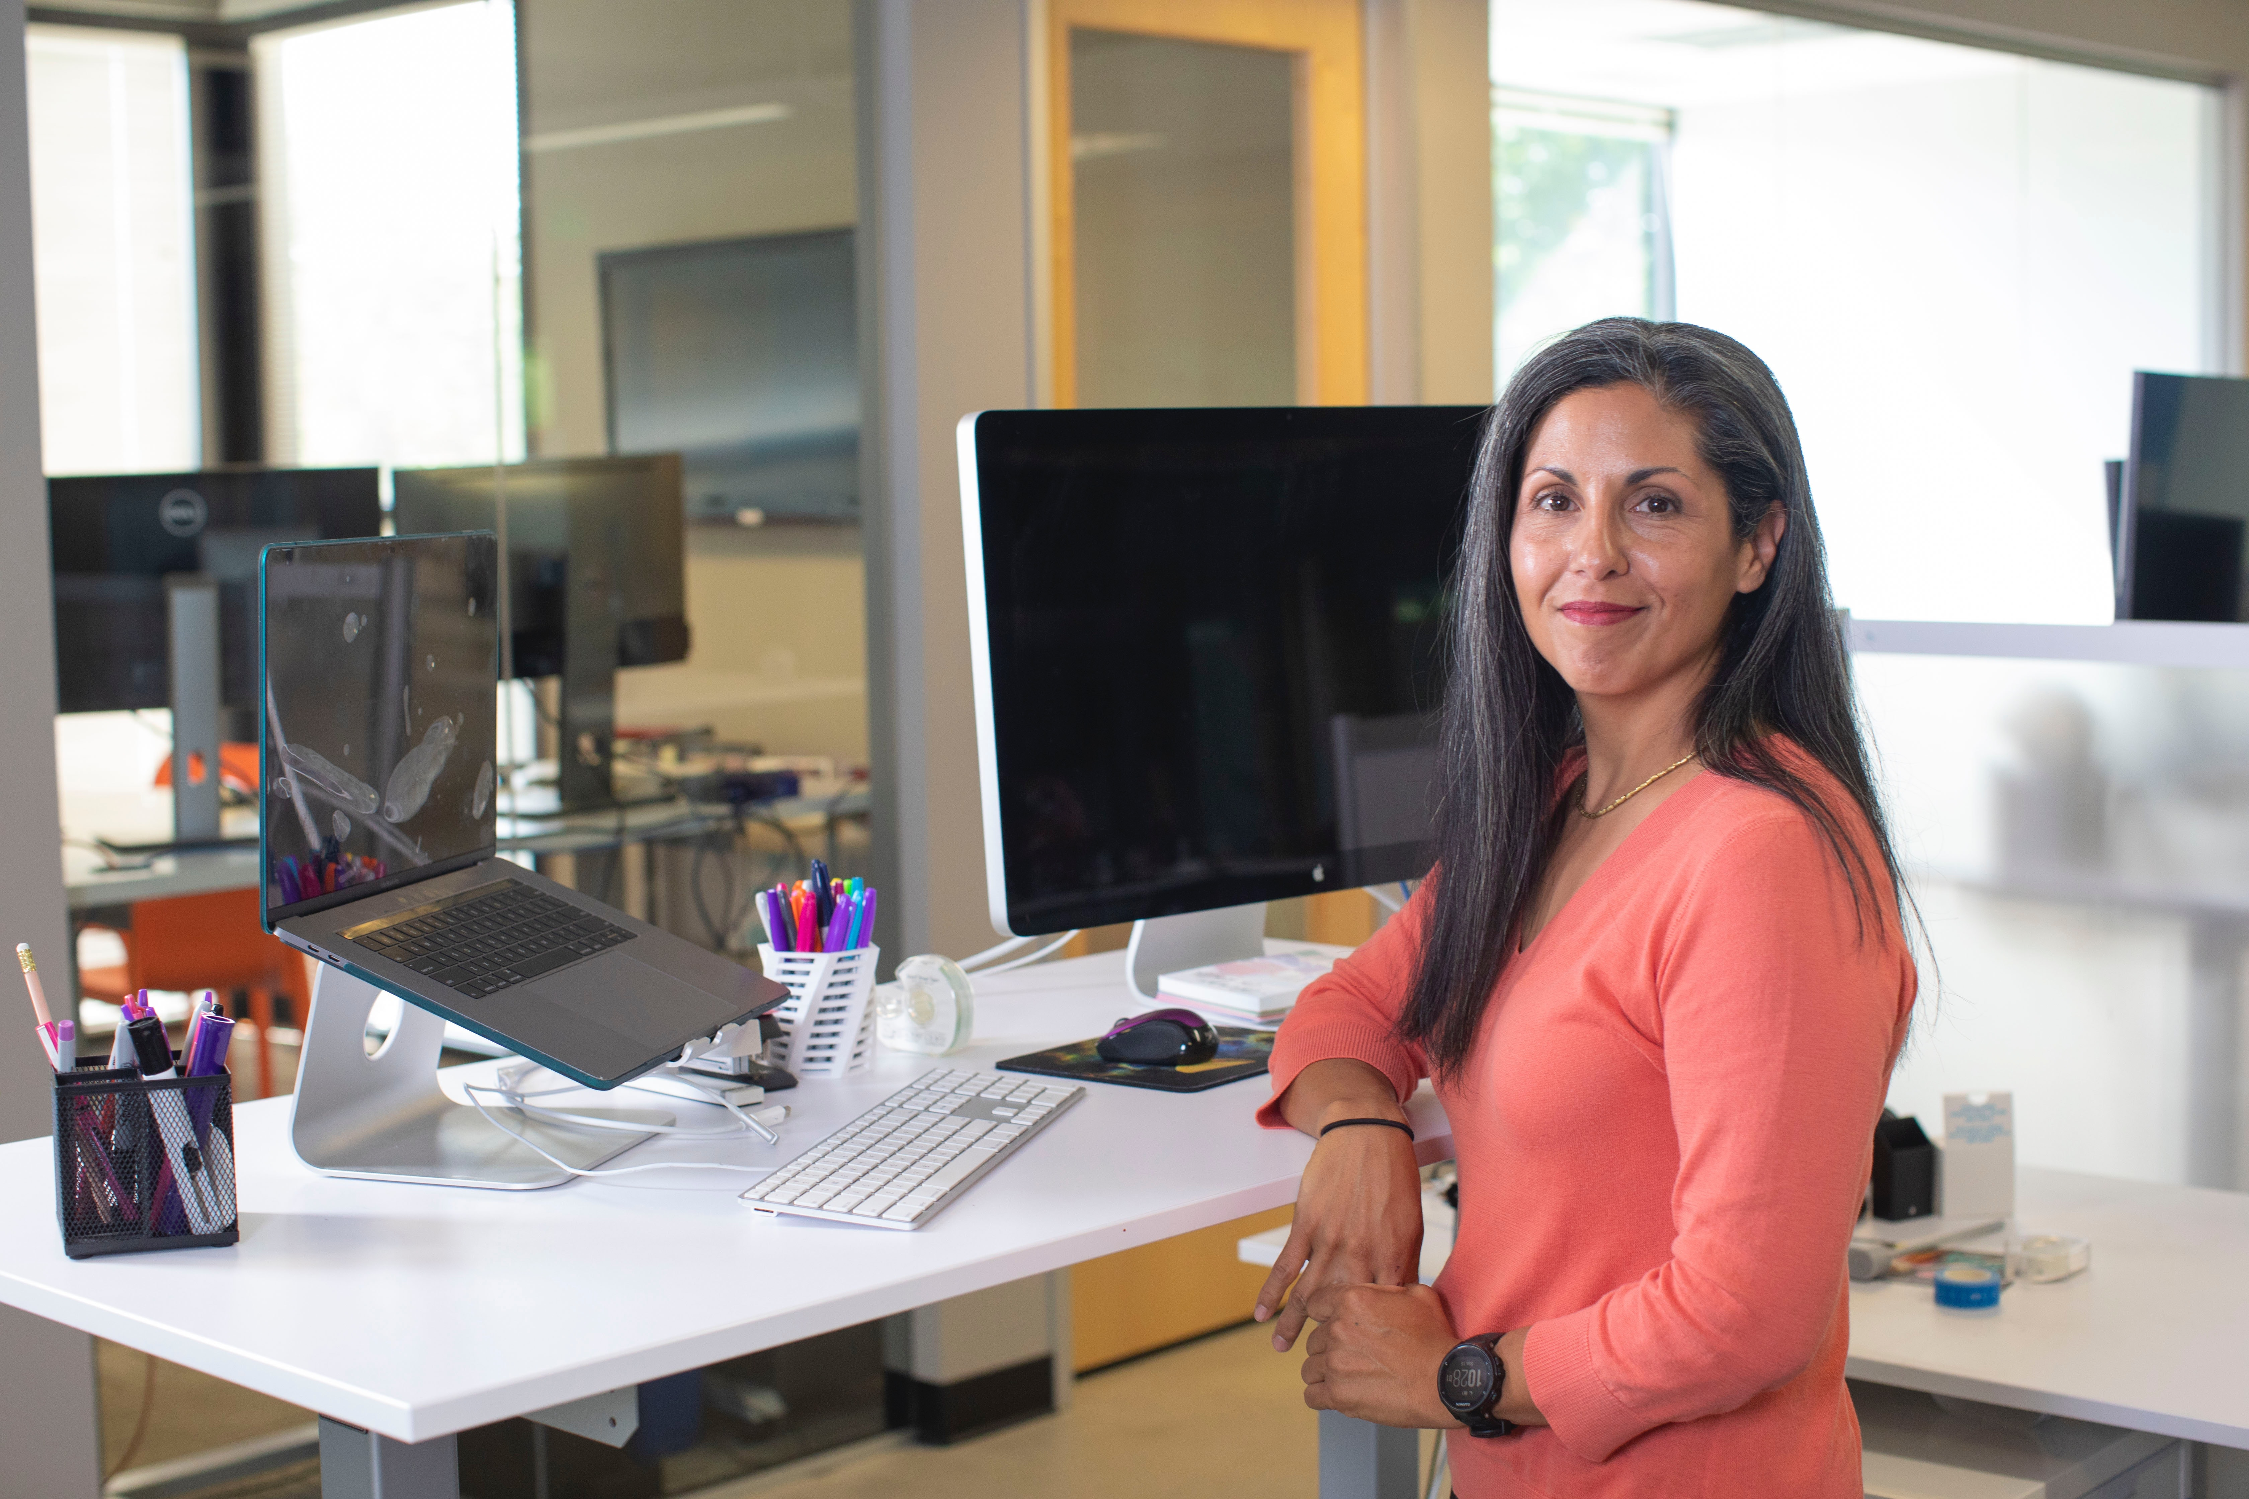

Persona #2 “Employee”:

Photo credits: Photo by [LinkedIn Sales Navigator](https://unsplash.com/@linkedinsalesnavigator?utm_source=unsplash&utm_medium=referral&utm_content=creditCopyText) on [Unsplash](https://unsplash.com/s/photos/woman-on-computer?utm_source=unsplash&utm_medium=referral&utm_content=creditCopyText) https://unsplash.com/photos/4nu1d0HYwAg

Demographic:

Age:32

Gender: Female

Status: Single

Educational Level: Masters degree

Native Languages: English

Description: Emily is an employee at a graphic design company. She works long hours and work can be stressful at times. She wants to learn new ways to help reduce stress and anxiety.

Expertise:

Technical Expertise: 9/10

Domain Expertise: 8/10

Goals:

1. Use the platform as a guide to learn new techniques to reduce stress/anxiety

2. Reduce overall stress and anxiety levels

3. Clear her mind and relax

4. Function better at work

5. Less anxiety

6. Improved creative flow

Motivations

1. Reduced stress

2. Improved cognitive function

3. Improved productivity

4. Decrease frustration

Frustrations

1. Just needs a simple way to get her mind into a better, more peaceful headspace.

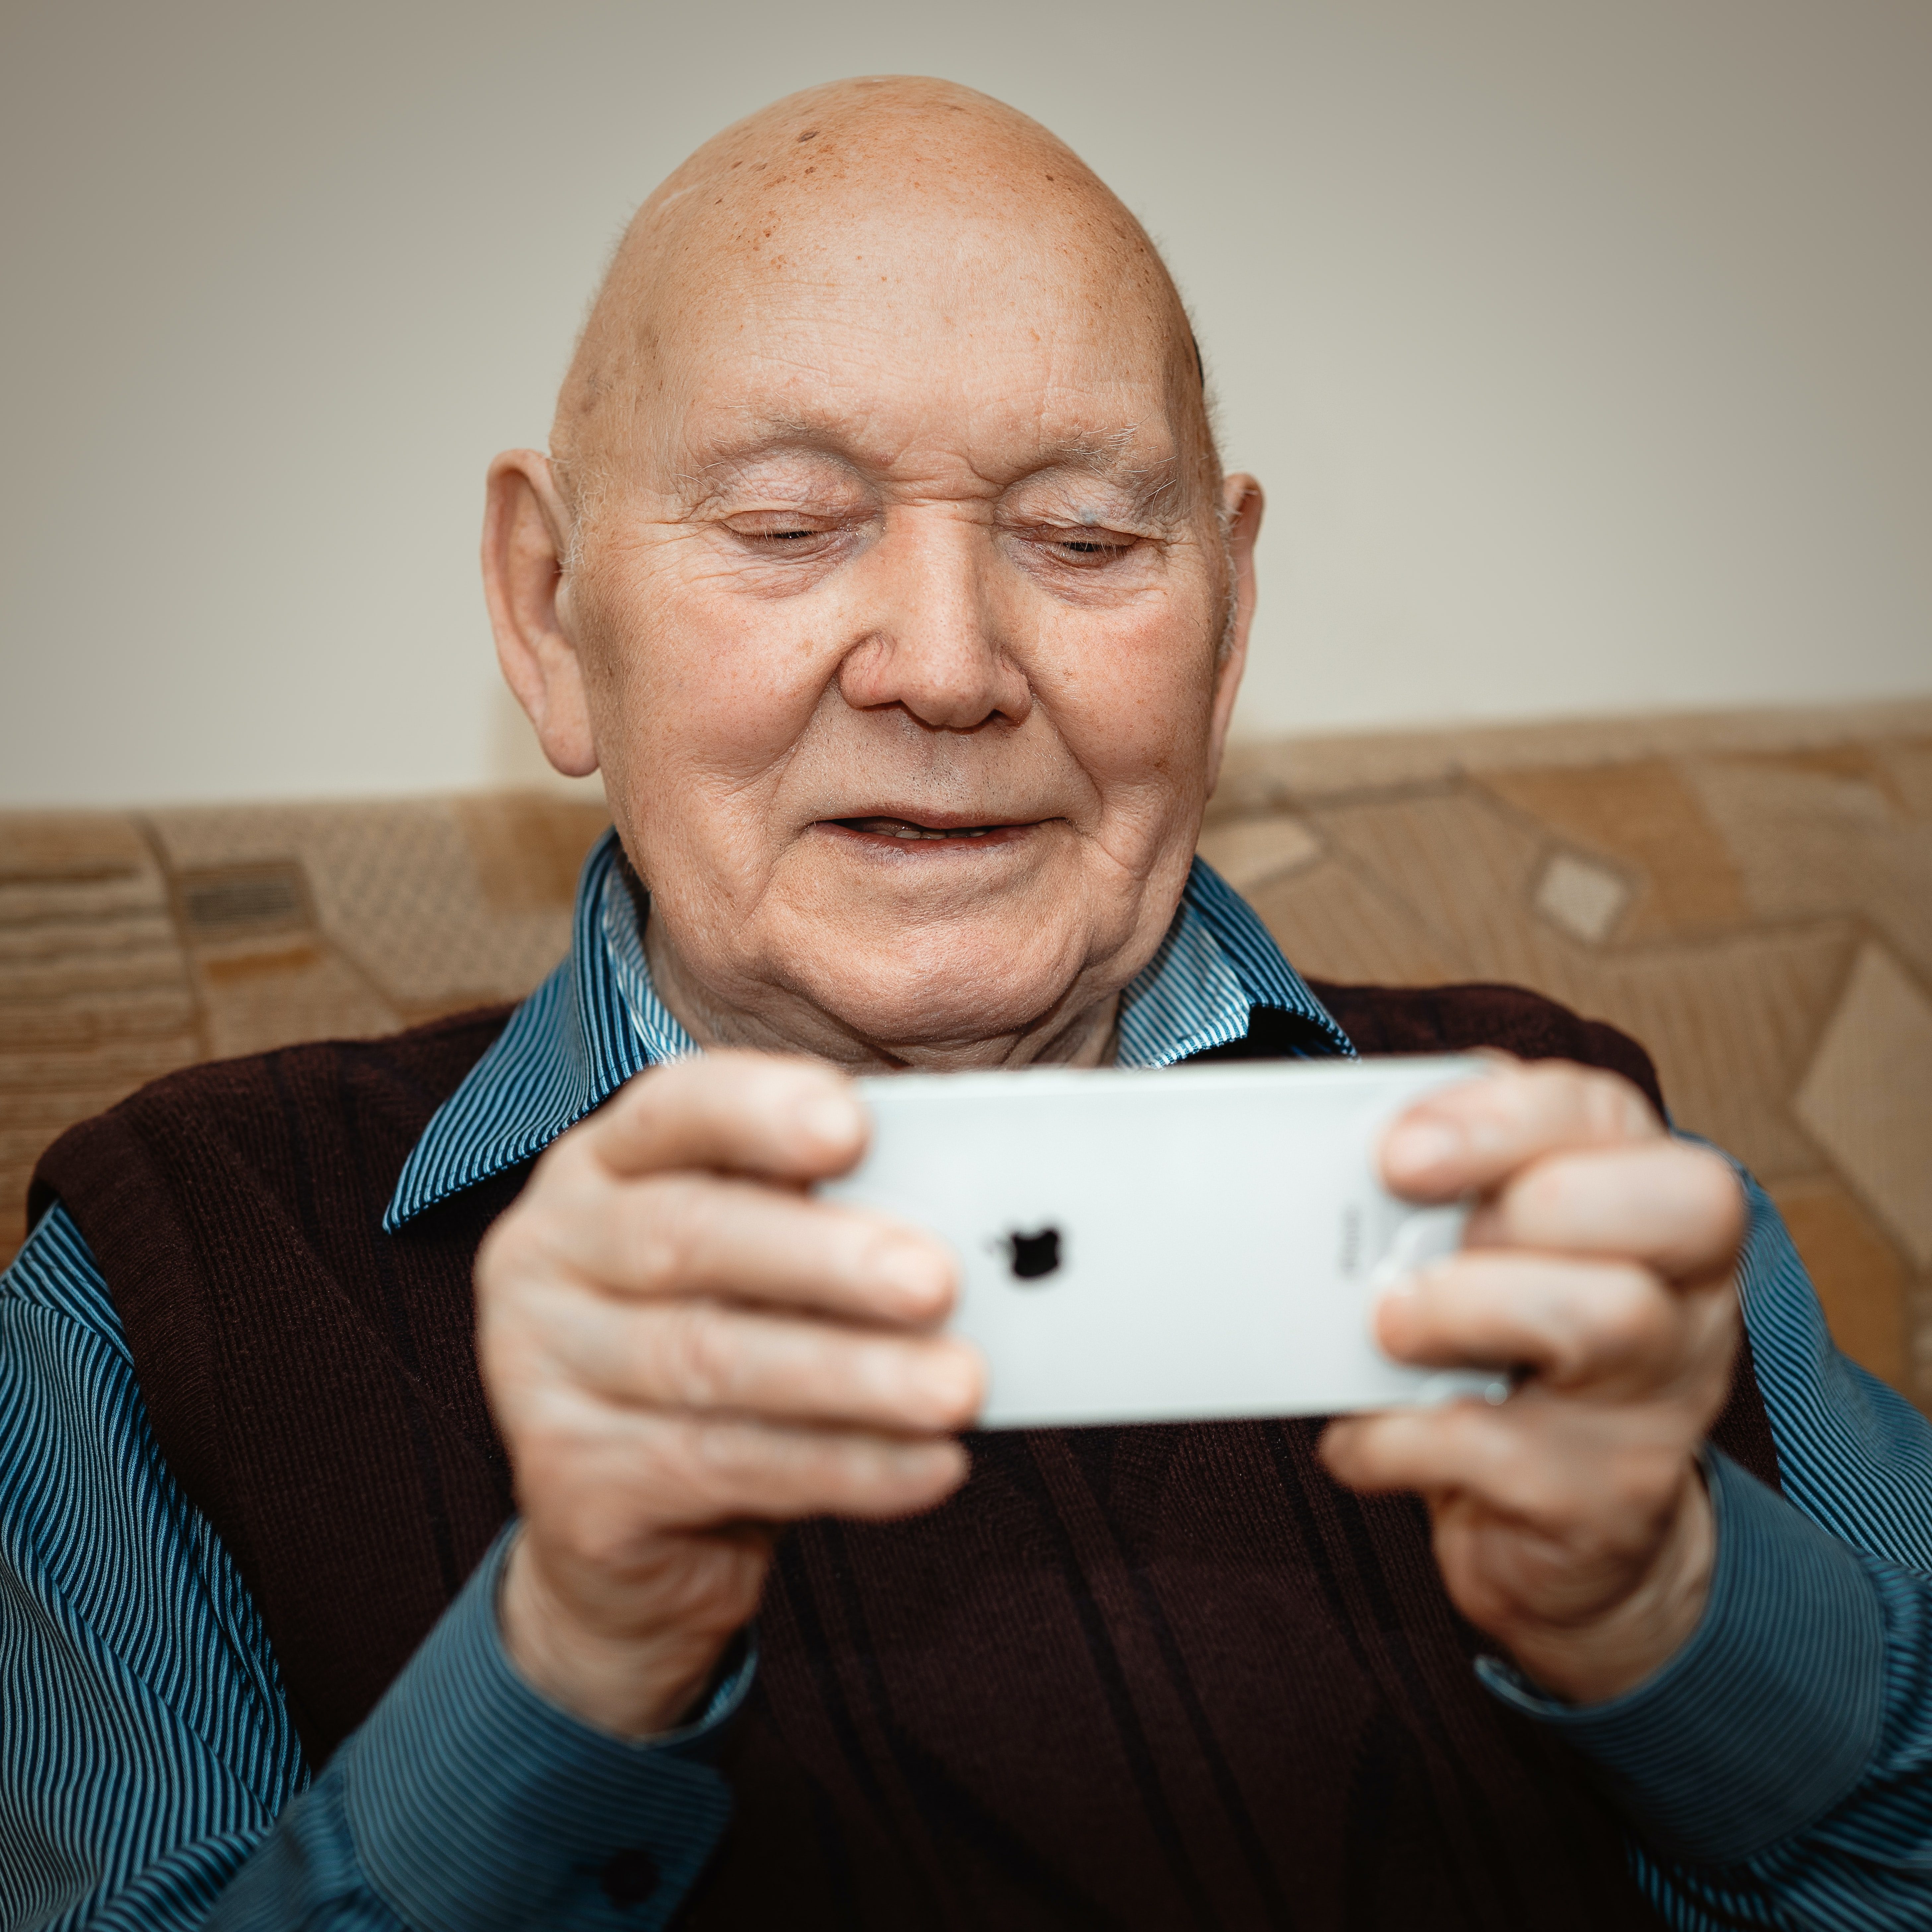

Persona #3 “Retiree”:

Photo credits: Photo by [Adam Nieścioruk](https://unsplash.com/@adamsky1973?utm_source=unsplash&utm_medium=referral&utm_content=creditCopyText) on [Unsplash](https://unsplash.com/s/photos/retired-man?utm_source=unsplash&utm_medium=referral&utm_content=creditCopyText) https://unsplash.com/photos/9ChfwZzv4ys

Demographic:

Age:70

Gender: Male

Status: Married

Educational Level: Bachelors degree

Native Languages: English

Description: Mike is a retired teacher. He does not have that much experience using the internet or mobile applications. He seeking an intuitive app that is very easy to use.

Expertise:

Technical Expertise: 6/10

Domain Expertise: 5/10

Goals:

1. Use the platform to learn new meditation techniques

2. Use the platform as an assistant to help reduce stress

3. Enhance relaxation

Motivations

1. Desire to learn new meditation and relaxation techniques

2. Reduce stress and anxiety

3. Provide background noise

Frustrations

1. A lot of apps are not user friendly at all and are very unintuitive to use

2. Most apps seem too complex and do not get straight to the point

2. I want an app that is not only easy and simple to use, but also quick and to the point